Project Planning
Project Title: Emotion-Aware Personalized Learning Platform using BiLSTM, BERT & Gemini AI Project Type: Individual Project Developed By: Single Student Developer (Individual Contributor)

1. Product Backlog
Sprint | Functional Requirement (Epic) | User Story Number | User Story / Task | Story Points | Priority
Sprint 1 | Project Setup & Environment Configuration | US-1 | Set up Python development environment and install required libraries (TensorFlow, Keras, NLTK, Hugging Face, Streamlit, Plotly, Pandas, NumPy, Scikit-learn) | 3 | High
Sprint 1 | Project Setup & Environment Configuration | US-2 | Configure Google Gemini AI API access for the application | 2 | High
Sprint 1 | Project Setup & Environment Configuration | US-3 | Collect and organize the Student Emotion Dataset | 3 | High
Sprint 2 | Data Preprocessing | US-4 | Implement text cleaning and preprocessing pipeline using NLTK | 5 | High
Sprint 2 | Data Preprocessing | US-5 | Format preprocessed text for BiLSTM model input | 3 | Medium
Sprint 2 | Data Preprocessing | US-6 | Format preprocessed text for BERT tokenizer input | 3 | Medium
Sprint 3 | BiLSTM Emotion Prediction | US-7 | Design and build the BiLSTM model architecture using TensorFlow/Keras | 8 | High
Sprint 3 | BiLSTM Emotion Prediction | US-8 | Train the BiLSTM model on the Student Emotion Dataset | 5 | High
Sprint 3 | BiLSTM Emotion Prediction | US-9 | Evaluate BiLSTM model prediction accuracy | 3 | Medium
Sprint 4 | BERT Emotion Prediction | US-10 | Fine-tune the Hugging Face BERT model on the Student Emotion Dataset | 8 | High
Sprint 4 | BERT Emotion Prediction | US-11 | Evaluate BERT model prediction accuracy | 3 | Medium
Sprint 4 | BERT Emotion Prediction | US-12 | Compare BiLSTM and BERT prediction outputs | 3 | Medium
Sprint 5 | Hybrid Decision Engine & Gemini AI Guidance | US-13 | Implement confidence score calculation logic | 3 | High
Sprint 5 | Hybrid Decision Engine & Gemini AI Guidance | US-14 | Implement mixed emotion detection logic | 5 | High
Sprint 5 | Hybrid Decision Engine & Gemini AI Guidance | US-15 | Implement final emotion decision engine combining BiLSTM and BERT outputs | 5 | High
Sprint 5 | Hybrid Decision Engine & Gemini AI Guidance | US-16 | Integrate Google Gemini AI to generate personalized learning guidance from the final emotion | 5 | High
Sprint 6 | User Interface, Analytics & Logging | US-17 | Build the Streamlit interface for student text input and result display | 5 | High
Sprint 6 | User Interface, Analytics & Logging | US-18 | Implement CSV interaction logging for every prediction | 3 | Medium
Sprint 6 | User Interface, Analytics & Logging | US-19 | Build the analytics dashboard using Plotly | 5 | Medium
Sprint 7 | Testing & Deployment | US-20 | Perform functional testing across all modules | 3 | High
Sprint 7 | Testing & Deployment | US-21 | Perform performance/latency testing on the prediction pipeline | 2 | Medium
Sprint 7 | Testing & Deployment | US-22 | Implement error handling for invalid input and API failures | 3 | High
Sprint 7 | Testing & Deployment | US-23 | Final deployment of the Streamlit application | 2 | High

2. Sprint Schedule
Sprint | Total Story Points | Duration | Planned Start Date | Planned End Date | Story Points Completed | Actual Release Date
Sprint 1 | 8 | 2 Weeks | 06 Jan 2026 | 19 Jan 2026 | 8 | 19 Jan 2026
Sprint 2 | 11 | 2 Weeks | 20 Jan 2026 | 02 Feb 2026 | 11 | 02 Feb 2026
Sprint 3 | 16 | 2 Weeks | 03 Feb 2026 | 16 Feb 2026 | 16 | 16 Feb 2026
Sprint 4 | 14 | 2 Weeks | 17 Feb 2026 | 02 Mar 2026 | 14 | 02 Mar 2026
Sprint 5 | 18 | 2 Weeks | 03 Mar 2026 | 16 Mar 2026 | 18 | 16 Mar 2026
Sprint 6 | 13 | 2 Weeks | 17 Mar 2026 | 30 Mar 2026 | 13 | 30 Mar 2026
Sprint 7 | 10 | 2 Weeks | 31 Mar 2026 | 13 Apr 2026 | 10 | 13 Apr 2026
Total Duration: 14 Weeks (7 Sprints × 2 Weeks)

3. Project Velocity Calculation
Metric | Value
Total Story Points (all sprints) | 8 + 11 + 16 + 14 + 18 + 13 + 10 = 90
Number of Sprints | 7
Average Story Points per Sprint | 90 ÷ 7 = 12.86 ≈ 13
Average Velocity | Since all planned story points were completed within each sprint, Average Velocity = Total Story Points Completed ÷ Number of Sprints = 90 ÷ 7 = 12.86 story points/sprint
Interpretation: As an individual project, velocity remained consistent across sprints (ranging from 8 to 18 story points), reflecting steady, predictable progress with heavier sprints (Sprint 3, 4, and 5) aligned to the more complex model-development and integration work (BiLSTM training, BERT fine-tuning, and Gemini AI integration).

4. Sprint Burndown Chart
The chart below tracks story points remaining across all 7 sprints, comparing the ideal (constant velocity) burndown against the actual burndown achieved.
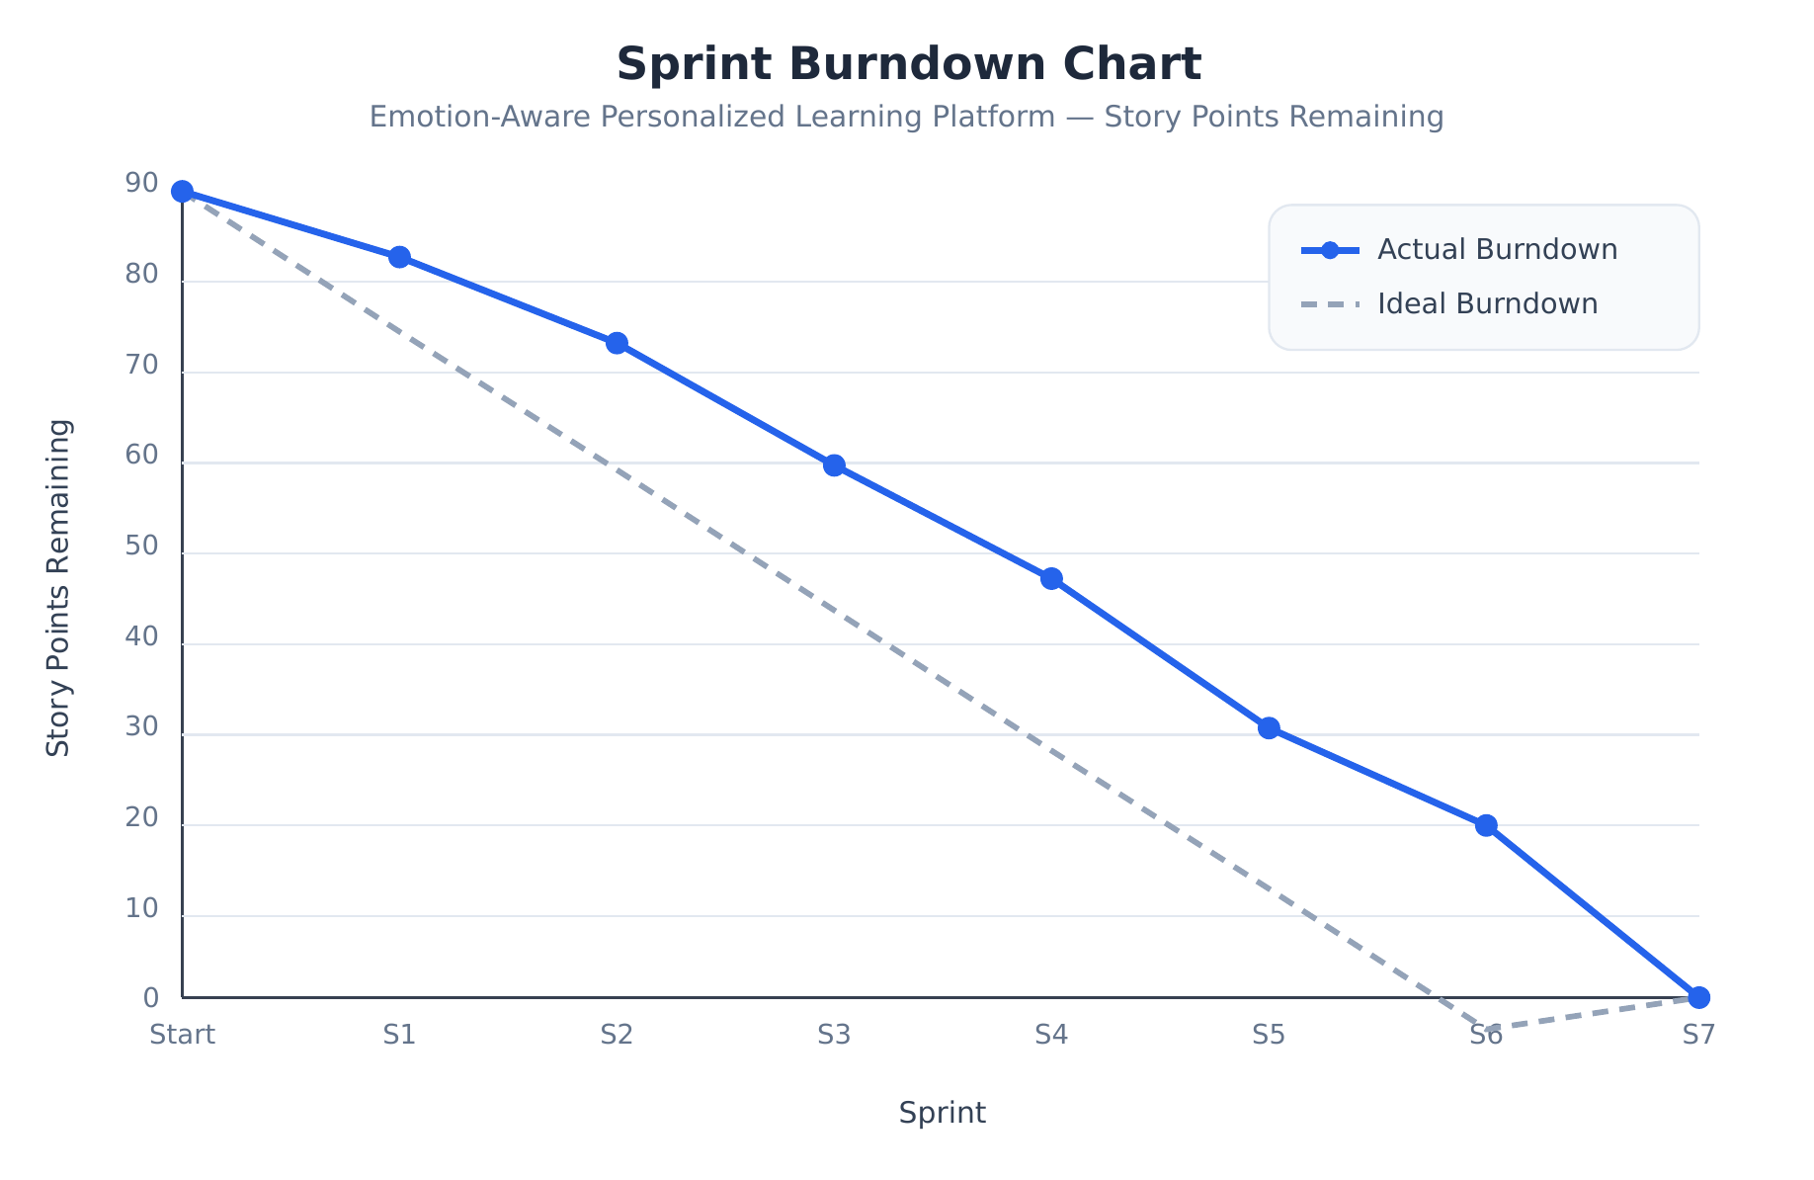
Sprint Burndown Chart
Sprint | Story Points Remaining (Actual) | Story Points Remaining (Ideal)
Start | 90 | 90
Sprint 1 | 82 | 77.14
Sprint 2 | 71 | 64.29
Sprint 3 | 55 | 51.43
Sprint 4 | 41 | 38.57
Sprint 5 | 23 | 25.71
Sprint 6 | 10 | 12.86
Sprint 7 | 0 | 0
(An editable SVG version of this chart, burndown_chart.svg, is included alongside this document.)

5. Project Milestones
Milestone | Description | Associated Sprints | Status
Milestone 1: Requirement Analysis & System Design | Problem statements, requirements, technology stack, and solution architecture finalized | Pre-Sprint 1 | Completed
Milestone 2: Environment Setup & Initial Configuration | Development environment, libraries, dataset, and Gemini API access configured | Sprint 1 | Completed
Milestone 3: Core System Development | Text preprocessing, BiLSTM training, and BERT fine-tuning completed | Sprint 2 – Sprint 4 | Completed
Milestone 4: Integration & Optimization | Confidence scoring, mixed emotion detection, final decision engine, and Gemini AI guidance integrated; Streamlit UI, dashboard, and CSV logging built | Sprint 5 – Sprint 6 | Completed
Milestone 5: Testing & Validation | Functional testing, performance testing, error handling, and final deployment completed | Sprint 7 | Completed

6. Sprint Delivery Plan
Sprint | Focus Area | Key Deliverables
Sprint 1 | Environment Setup | Configured Python environment, required libraries installed, Gemini API access configured, Student Emotion Dataset collected
Sprint 2 | Data Preprocessing | Text cleaning pipeline (NLTK), preprocessed data formatted for both BiLSTM and BERT
Sprint 3 | BiLSTM Model Development | BiLSTM architecture built, trained, and evaluated
Sprint 4 | BERT Model Development | BERT model fine-tuned, evaluated, and compared against BiLSTM
Sprint 5 | Hybrid Decision Engine & Gemini AI | Confidence scoring, mixed emotion detection, final emotion decision logic, and Gemini AI guidance integration completed
Sprint 6 | Interface, Analytics & Logging | Streamlit UI, Plotly analytics dashboard, and CSV interaction logging completed
Sprint 7 | Testing & Deployment | Functional testing, performance testing, error handling, and final deployment completed

7. Project Progress Tracking
Module | Sprint | Planned | Status
Environment Setup | Sprint 1 | Yes | Completed
Dataset Collection | Sprint 1 | Yes | Completed
Data Preprocessing | Sprint 2 | Yes | Completed
BiLSTM Training | Sprint 3 | Yes | Completed
BERT Fine-tuning | Sprint 4 | Yes | Completed
Confidence Score Calculation | Sprint 5 | Yes | Completed
Mixed Emotion Detection | Sprint 5 | Yes | Completed
Final Emotion Decision Engine | Sprint 5 | Yes | Completed
Gemini AI Integration | Sprint 5 | Yes | Completed
Streamlit User Interface | Sprint 6 | Yes | Completed
Analytics Dashboard | Sprint 6 | Yes | Completed
CSV Interaction Logging | Sprint 6 | Yes | Completed
Functional Testing | Sprint 7 | Yes | Completed
Performance Testing | Sprint 7 | Yes | Completed
Error Handling | Sprint 7 | Yes | Completed
Final Deployment | Sprint 7 | Yes | Completed
Overall Project Status: All 7 sprints and 16 tracked modules completed as planned, with an average velocity of approximately 12.86 story points per sprint across the individual project timeline.

